

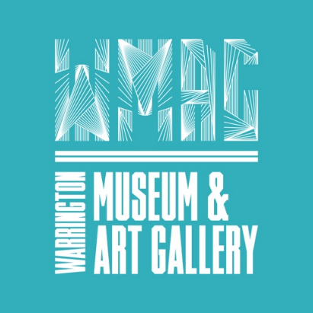

30th November



9am-3pm

**St Andrew’s Church, Poplars Avenue, Orford, WA2 9UE**

Bring along your

own photos & share

the memories!

**St Andrew’s Day Community Service** at **9am**

with School - Led by Yr2 & Yr5

**Orford Through the Years Exhibition**

with Warrington Museum Services

**Local History Display** produced by Yr6

**Story Telling** with Orford Library

**Mystery Items** identifying objects from the past

**Musical Interlude** at **12 O’clock**

Popular songs performed by our own Organist **Peter Thirsk**

**Refreshments Available**